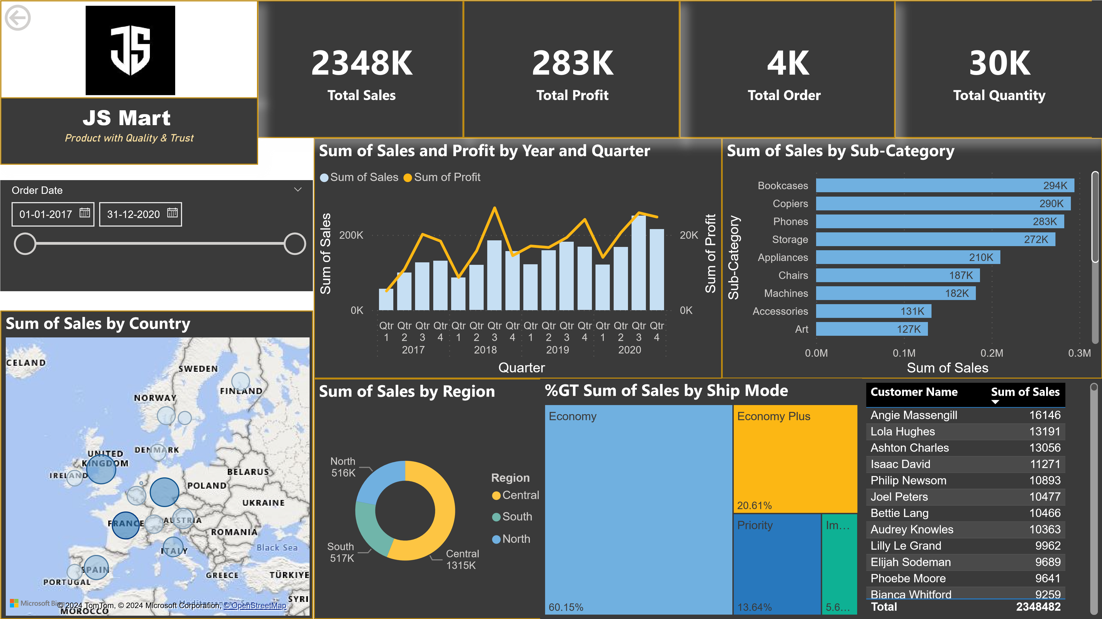

Power BI Desktop

|  |  |  |  |  |  |
| --- | --- | --- | --- | --- | --- |
| |  |  |  | | --- | --- | --- | | 1836  Sum of Profit |  | 3.70  Sum of Discount | | |  | | --- | | 29  Count of Return Status | |

11Sum of Sales11Sum of Sales11KKK

Sum of Sales

|  |  |  |  |  |  |  |  |  |  |  |  |  |  |  |  |  |  |  |  |  |  |  |  |  |  |  |  |  |  |  |  |  |  |  |  |  |  |  |  |  |  |  |  |  |  |  |  |  |  |  |  |  |  |  |  |  |  |  |  |  |  |  |  |  |  |  |  |  |  |  |  |
| --- | --- | --- | --- | --- | --- | --- | --- | --- | --- | --- | --- | --- | --- | --- | --- | --- | --- | --- | --- | --- | --- | --- | --- | --- | --- | --- | --- | --- | --- | --- | --- | --- | --- | --- | --- | --- | --- | --- | --- | --- | --- | --- | --- | --- | --- | --- | --- | --- | --- | --- | --- | --- | --- | --- | --- | --- | --- | --- | --- | --- | --- | --- | --- | --- | --- | --- | --- | --- | --- | --- | --- |
| |  |  |  |  |  |  |  |  |  |  |  |  |  |  |  |  |  |  |  |  |  |  |  |  |  |  |  |  |  |  |  |  |  |  |  |  |  |  |  |  |  |  |  |  |  | | --- | --- | --- | --- | --- | --- | --- | --- | --- | --- | --- | --- | --- | --- | --- | --- | --- | --- | --- | --- | --- | --- | --- | --- | --- | --- | --- | --- | --- | --- | --- | --- | --- | --- | --- | --- | --- | --- | --- | --- | --- | --- | --- | --- | --- | | |  |  |  |  | | --- | --- | --- | --- | | Customer Name | Country   | State | City | | Isaac David | Denmark | Hovedstaden | Copenhagen | | Isaac David | France | Aquitaine-Limousin-Poitou-Charentes | La Rochelle | | Isaac David | France | Languedoc-Roussillon-Midi-Pyrénées | Perpignan | | Isaac David | France | Normandy | Vernon | | Isaac David | Germany | Baden-Württemberg | Friedrichshafen | | Isaac David | Germany | Hamburg | Hamburg | | Isaac David | Netherlands | North Holland | Amsterdam | | Isaac David | Netherlands | South Holland | The Hague | | Isaac David | Spain | Catalonia | Castelldefels | | Isaac David | United Kingdom | England | Nottingham | | | |  |  |  |  |  |  |  |  |  |  |  |  |  |  |  |  |  |  |  |  |  |  |  |  |  | | --- | --- | --- | --- | --- | --- | --- | --- | --- | --- | --- | --- | --- | --- | --- | --- | --- | --- | --- | --- | --- | --- | --- | --- | --- | | |  |  | | --- | --- | | Acco Binder, Clear | 1 | | Acco Hole Reinforcements, Recycled | 1 | | Accos Thumb Tacks, Assorted Sizes | 1 | | Apple Office Telephone, VoIP | 2 | | Binney & Smith Pencil Sharpener, Water Color | 1 | | Brother Fax and Copier, Digital | 1 | | Bush Stackable Bookrack, Mobile | 1 | | Cardinal 3-Hole Punch, Durable | 1 | | Enermax Note Cards, 8.5 x 11 | 1 | | Hoover Refrigerator, Silver | 1 | | Jiffy Clasp Envelope, Recycled | 1 | | KitchenAid Refrigerator, Black | 1 |   Product Name Count of Quantity  Kleencut Scissors, Easy Grip 1  **Total 29** | |

Power BI Desktop

|  |  |  |
| --- | --- | --- |
|  | |  | | --- | | Economy plus - copiers is the best subcategory (sales amount 68k) | |